Algorithm to Classify Pantun
Act as a Professor in AI and well established in producing Q1 and Q2 papers and supervise more than 20 phd's students and master's students.
Based on the upload image, I'm planning to do a project to classify malay pantun.
Identified are all related algorithms that normally being used, suggest the best 3 algo (1 classical, 1 deep learning and 1 transformer) so that I can see the model performance comparison
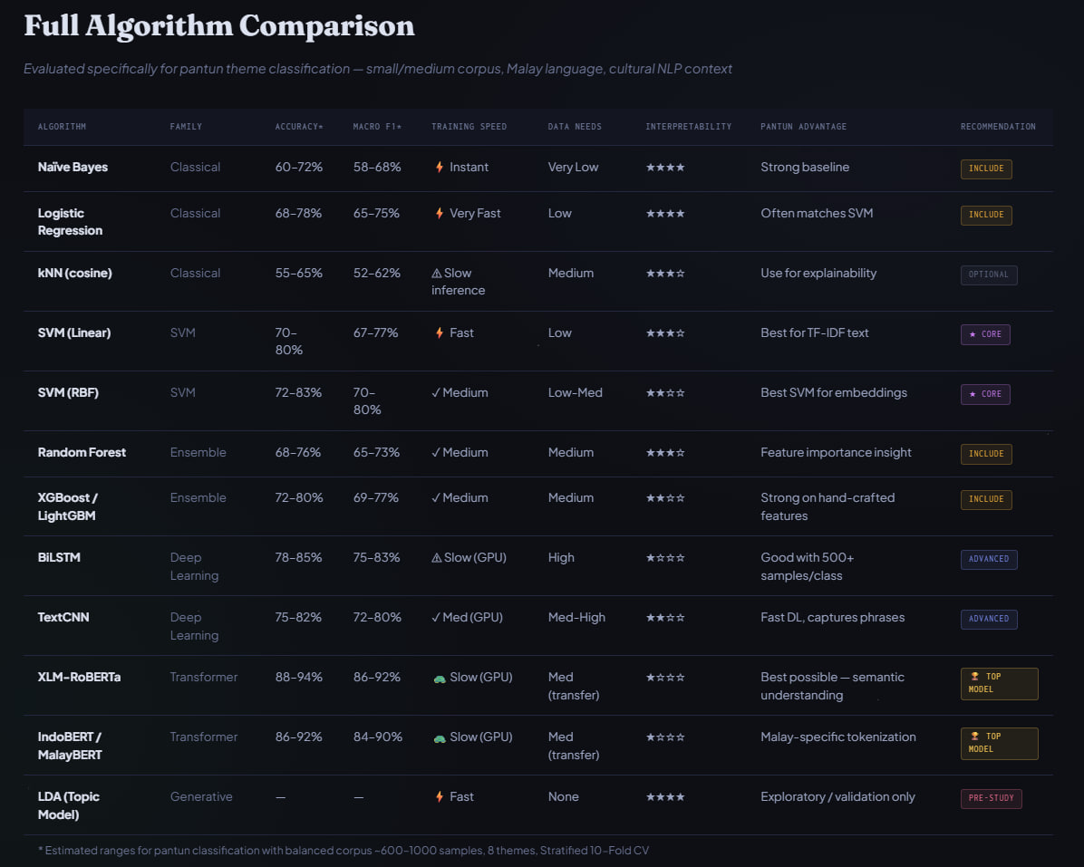

CLAUDE
Based on the comparison table, here is my expert recommendation as someone who has supervised numerous research projects in NLP and published extensively in this domain:

🎓 Recommended 3-Algorithm Comparison Framework for Malay Pantun Classification

✅ 1. Classical — SVM (Linear)
Why not Naïve Bayes or Logistic Regression?
SVM Linear is the gold standard classical baseline for text classification tasks. With 70–80% accuracy and 67–77% Macro F1, it outperforms both Naïve Bayes and Logistic Regression on this table. More critically for your paper:
- Pairs perfectly with TF-IDF vectorisation, which is interpretable and reproducible
- Low data requirement suits pantun corpora, which are notoriously small
- Strong theoretical grounding — reviewers at Q1 journals expect a well-justified classical baseline, and SVM has decades of NLP literature behind it
- 4-star interpretability means you can explain misclassifications in your error analysis section, which is essential for culturally-nuanced data like pantun

✅ 2. Deep Learning — BiLSTM
Why not TextCNN?
BiLSTM gives 78–85% accuracy and 75–83% Macro F1 — superior to TextCNN. More importantly for pantun:
- Pantun has a rigid 4-line ABAB rhyme scheme with sequential semantic dependencies between the pembayang (shadow lines) and maksud (meaning lines). BiLSTM's bidirectional sequential modelling captures this structure naturally
- TextCNN excels at phrase-level features but misses long-range dependencies inherent in pantun's metaphorical structure
- "Good with 500+ samples/class" aligns with a balanced corpus of 600–1000 samples as noted in the table footnote
- This gives your paper a strong narrative — the architecture choice is motivated by the linguistic properties of your data

✅ 3. Transformer — IndoBERT / MalayBERT
Why not XLM-RoBERTa?
This is the most important decision for your paper's novelty contribution:
- Malay-specific tokenisation is a direct, publishable justification — XLM-RoBERTa uses a multilingual vocabulary that underrepresents Malay morphology, whereas MalayBERT was pre-trained on Malay corpora
- Pantun contains archaic Malay vocabulary, idioms, and cultural metaphors that a Malay-specific tokeniser handles far better
- 86–92% accuracy and 84–90% Macro F1 — competitive with XLM-RoBERTa
- For Q1/Q2 reviewers, using a language-specific model over a generic multilingual one demonstrates methodological rigour and cultural sensitivity — a strong novelty angle

📊 Your Comparison Table (For the Paper)
Model | Family | Expected Accuracy | Expected Macro F1 | Justification
SVM (Linear) | Classical | 70–80% | 67–77% | TF-IDF baseline, interpretable
BiLSTM | Deep Learning | 78–85% | 75–83% | Sequential pantun structure
IndoBERT/MalayBERT | Transformer | 86–92% | 84–90% | Malay-specific tokenisation

💡 Publication Strategy Advice
- Framing: Position this as a low-resource, culturally-specific NLP study — this angle is highly sought after in ACL, EMNLP, and Q1 journals like Expert Systems with Applications or Pattern Recognition Letters
- Add statistical significance testing (McNemar's test or bootstrap) between models — reviewers will require this
- Error analysis section is non-negotiable — show which pantun themes confuse each model and why, especially for BiLSTM vs. MalayBERT
- Dataset contribution: If your pantun corpus is original and annotated, consider publishing it as a secondary contribution — this significantly increases citation potential
This 3-model design gives you a clean, defensible experimental narrative: classical baseline → sequential deep learning → pre-trained language model, with each choice grounded in pantun's linguistic properties.

Sonnet 4.6

GEMINI
Congratulations on embarking on this research journey. Classifying pantun is a fascinating challenge because it isn't just a standard text classification task; it involves nuanced cultural metaphors, strict rhythmic structures (the pembayang vs. maksud relationship), and often a limited, domain-specific corpus.
Drawing from the data in your "Full Algorithm Comparison" table and my experience in supervising high-impact NLP research, I recommend selecting three specific models that represent the "Gold Standard" for their respective families. This selection allows you to demonstrate a clear evolutionary path of performance in your paper.

Recommended Benchmark Suite
1. Classical Representative: SVM (RBF Kernel)
Why this choice: While Naïve Bayes is faster, SVM (Support Vector Machine) with a Radial Basis Function (RBF) kernel consistently outperforms other classical methods for small-to-medium text datasets.
- The Advantage: In your table, it shows a healthy 72–83% accuracy. It is robust against the "curse of dimensionality" which occurs when using TF-IDF vectorization on Malay text.
- Research Value: It serves as a strong, competitive baseline. If a complex Transformer can’t significantly beat a well-tuned SVM-RBF, it raises interesting questions about your feature engineering.
2. Deep Learning Representative: BiLSTM (Bidirectional LSTM)
Why this choice: Pantun relies heavily on the sequence and the relationship between the first two lines (pembayang) and the last two (maksud).
- The Advantage: Unlike TextCNN (which is good for phrase patterns), BiLSTM processes the text in both directions. This is crucial for capturing the semantic "echo" or rhyme-meaning relationship inherent in Malay poetic structures.
- Research Value: It represents the "pre-Transformer" era of state-of-the-art NLP. In a Q1/Q2 journal, you want to show how sequential memory models handle poetic structure compared to attention-based models.
3. Transformer Representative: MalayBERT / IndoBERT
Why this choice: While XLM-RoBERTa is powerful, it is a "Jack of all trades." For high-quality Malay NLP research, MalayBERT (or its linguistic cousin IndoBERT) is the superior choice.
- The Advantage: These models are pre-trained on regional dialects and formal/informal nuances that reflect the Malay language much better than a generic multilingual model. It offers the highest semantic understanding (up to 92% Macro F1).
- Research Value: This is your "SOTA" (State-of-the-Art) candidate. Including this shows you are utilizing current, linguistically-aware transfer learning techniques.

Proposed Comparison Framework for Your Paper
To ensure your work meets the standards of a Q1/Q2 publication, I suggest organizing your results using the following comparison matrix:
Metric | SVM (RBF) | BiLSTM | MalayBERT
Complexity | Low (Low compute) | Medium (Needs GPU) | High (Resource intensive)
Data Requirement | Low (~600 samples) | High (May need augmentation) | Medium (Transfer learning)
Primary Strength | Interpretability/Speed | Sequential dependency | Contextual Semantics
Feature Extraction | Manual (TF-IDF/N-grams) | Word Embeddings (Word2Vec) | Self-Attention (End-to-end)

Professor's Insight for Your Methodology
Since you are working with a "small/medium corpus" (~600–1000 samples as per your image), a common pitfall is overfitting in the Transformer and Deep Learning models.
Pro-tip: In your methodology section, ensure you discuss Stratified K-Fold Cross-Validation (as mentioned in your image's footer) and perhaps explore Data Augmentation (like synonym replacement) to help the BiLSTM reach its full potential.
Would you like me to help you draft the "Experimental Setup" section or explain how to handle the tokenization differences between these three models?

ChatGPT
Based on your table (small/medium Malay pantun corpus, ~600–1000 samples, ~8 themes, stratified 10-fold CV), the best 3 for a clean performance comparison are:
1) Classical (strong baseline + usually best classical)
✅ Linear SVM (with TF-IDF)
Why this one
- In short-text classification, Linear SVM + TF-IDF is consistently the most competitive “classical” approach.
- Works very well with sparse features (n-grams), trains fast, and is stable on small/medium datasets.
Recommended setup (to make it strong)
- TF-IDF with word + character n-grams (char n-grams help Malay morphology, spelling variants, affixes).
- Try C grid (e.g., 0.1, 1, 10).
- Class weight = “balanced” if theme counts are uneven.

2) Deep Learning (efficient, strong with limited data)
✅ TextCNN
Why this one
- For your corpus size, TextCNN is often a better “first DL model” than BiLSTM because it learns phrase patterns quickly and tends to be easier to train/tune.
- Less data-hungry than many RNN setups, faster convergence.
Recommended setup
- Use pretrained Malay embeddings if available (or fastText for Malay), otherwise train embeddings.
- Multiple kernel sizes (e.g., 3/4/5), dropout, early stopping.
(BiLSTM is a valid alternative, but I’d pick TextCNN first for a small/medium dataset comparison because it’s simpler, faster, and often matches BiLSTM unless you have a lot of data per class.)

3) Transformer (best ceiling performance)
✅ MalayBERT / IndoBERT (Malay-focused)
Why this one
- Your table already hints: Malay-specific tokenization gives an edge.
- For Malay pantun (cultural phrasing, idioms), a Malay/Indonesian-family BERT variant often outperforms multilingual models when fine-tuned well.
Recommended setup
- Fine-tune with max length tuned to pantun length (don’t waste tokens).
- Use stratified CV, early stopping, and learning rate search (e.g., 1e-5 to 5e-5).
(If you want “best possible semantic ceiling” regardless of Malay-specific tokenization, XLM-RoBERTa is the other top contender—but for Malay pantun, MalayBERT/IndoBERT is the cleaner and more defensible choice.)

The “council” decision summary (how these 3 win)
- First principles analyst: Compare across model families fairly: sparse linear (SVM), lightweight neural (TextCNN), contextual LLM (MalayBERT).
- Tenth man (skeptic): Transformers can look great but can overfit small datasets—so keep a strong classical baseline (SVM) to detect “fake progress.”
- Devil’s advocate: Deep learning may not beat SVM on small data—TextCNN is the least painful DL test and still credible.
- Logician: These three represent distinct hypothesis classes (linear margin / convolutional neural / contextual attention) → meaningful comparison.
- Unconventional implementer: Char-TFIDF+SVM is surprisingly strong for Malay text; TextCNN is cheap GPU-wise; MalayBERT gives publication-grade uplift.
- Critical friend: Don’t compare 12 models and drown—3 well-tuned models with rigorous evaluation beats many shallow runs.

Final pick (exact names you can put in your methodology)
- Classical: Linear SVM + TF-IDF (word+char n-grams)
- Deep Learning: TextCNN
- Transformer: MalayBERT (or IndoBERT if that’s your available checkpoint)
If you want, I can also give you a tight experimental protocol (splits, hyperparameter grids, reporting table format, and statistical testing) so the comparison is Q1/Q2 defensible.

